**Table user**

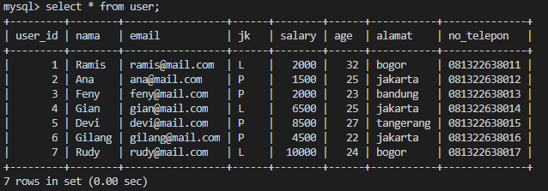

1. **Tampilkan data alamat di Jakarta**

Select * from user where alamat=’jakarta’;

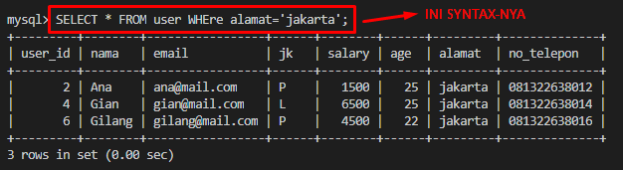

1. **Tampilkan jumlah data salary lebih dari 4500**

SELECT salary as salaryAge,count(salary) as banyak from user where salary>4500 group by salary

union all

select 'jumlah' salary,count(salary) from user where salary>4500;

1. **Tampilkan jumlah orang yang bergaji 2000**

SELECT salary,count(salary) as banyak from user where salary=2000;

1. **Tampilkan jumlah orang berumur 23 & 25**

SELECT age,count(age) as banyak FROM user where age in(23,25) group by age

UNION ALL

SELECT 'jumlah' age,count(age) from user where age in(23,25);

Output :

